Virtual Voting Template #1
To be used by a group to document the number of votes for each idea or topic

Completed Example
Customize the text in the brackets for your project
What places should we go to collect data?
Type your name next to the idea to vote for that idea.
You can make 2 votes.

Place to collect data | Votes
Community centers  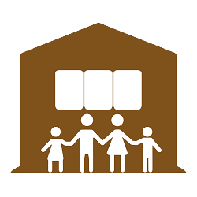 | Jamie  Shawna
Parks  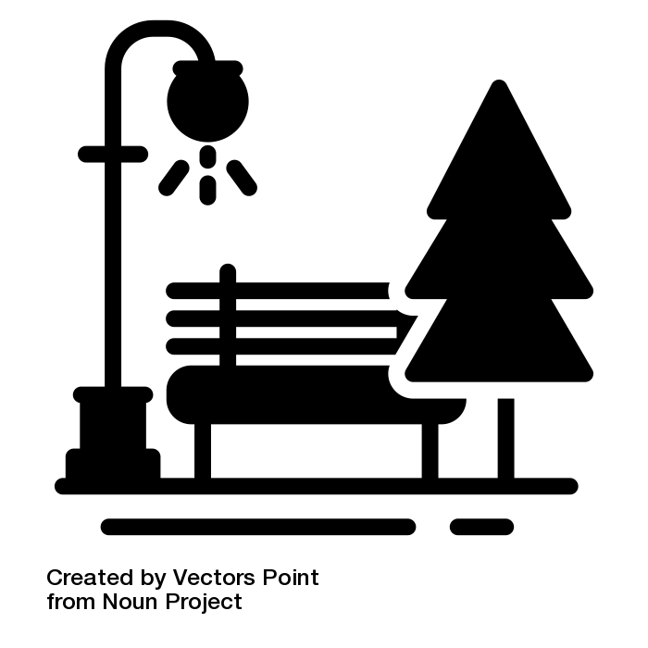 | Marco  Mary  Jamie
Restaurants  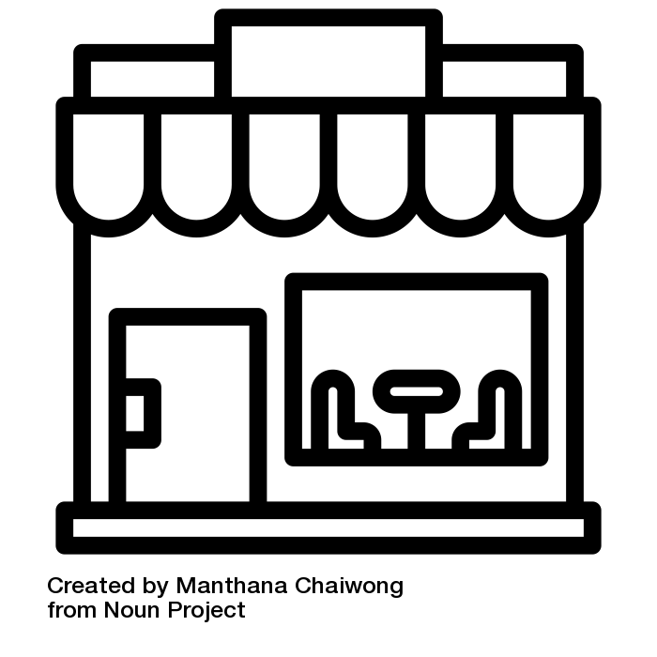 | Taylor  Shawna
Schools   | Mary  Marco  Taylor

Blank Template
Customize the text in the brackets for your project
What [ideas do you think are the best /topics do you think are most important/ issues are most important to other people with disabilities]?
[Type your initials/place your icon] next to the idea to vote for that idea.
You can make [three] votes.

Topic / Idea | Votes

